**Types of databases:**

1. SQL -> Structured Query Language ( MySQL, MSSQL, DB2, oracle)
2. NoSQL -> Not Only SQL (MongoDB, cassandra, HBase, Neo4j)

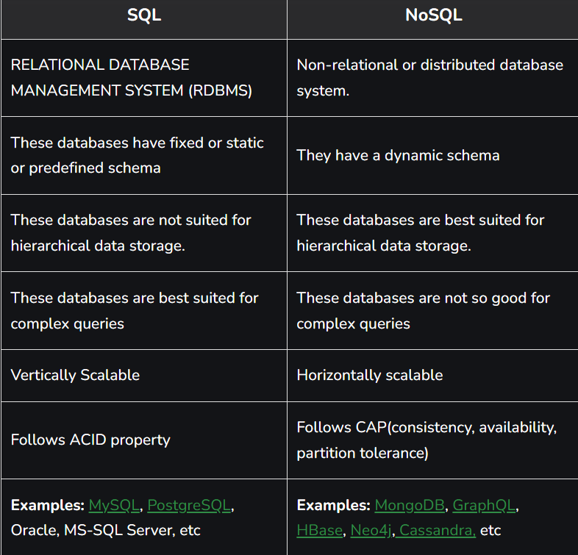

OPEN VISUAL STUDIO CODE:



Enter a username and password and click on “CONNECT”

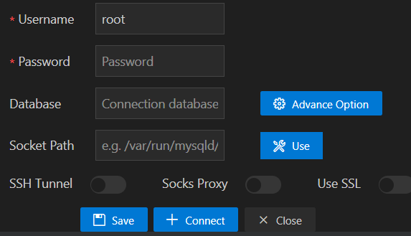

After connecting, Add a database ‘test’

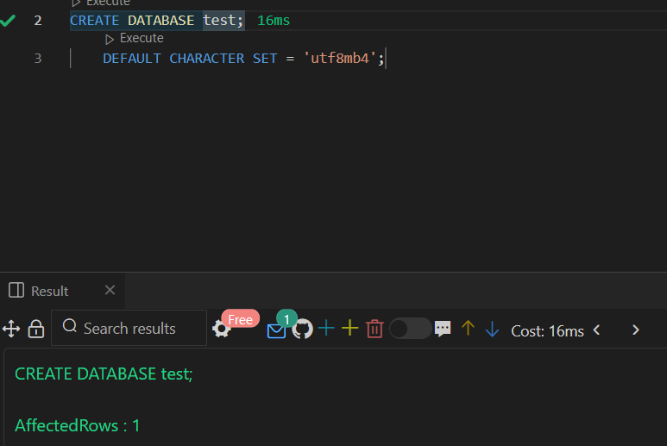

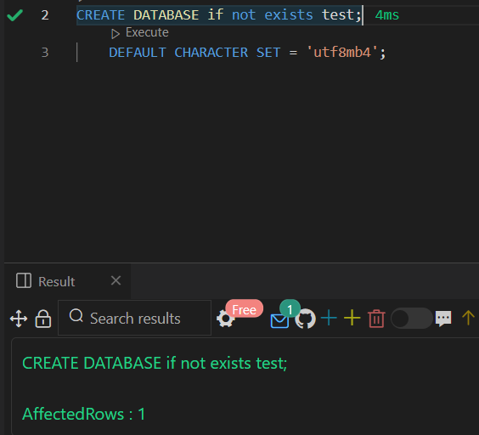

Now, we add a table ‘test_table’ in database ‘test’

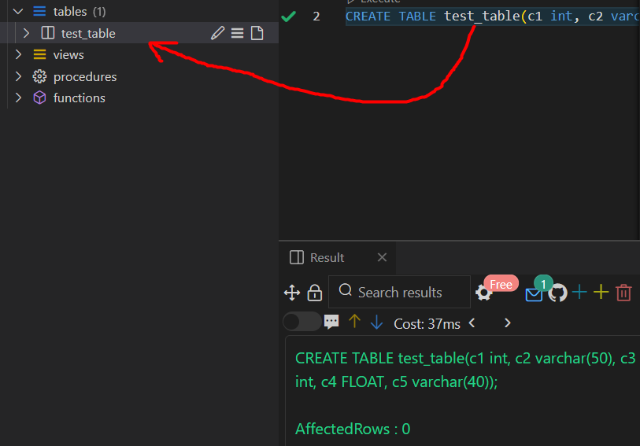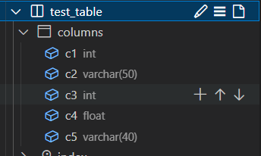

In order to avoid error, you can write: Create table if not exists test_table()

Consider, we want to perform the following in Python. The main task we have to do first is BUILD THE CONNECTION between SQL and Python Programming Language.

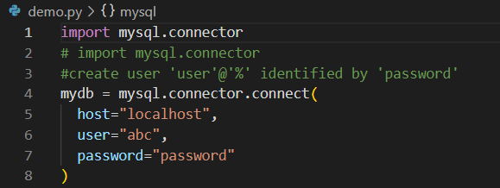

In this way, you can create a connection between Python and Database.

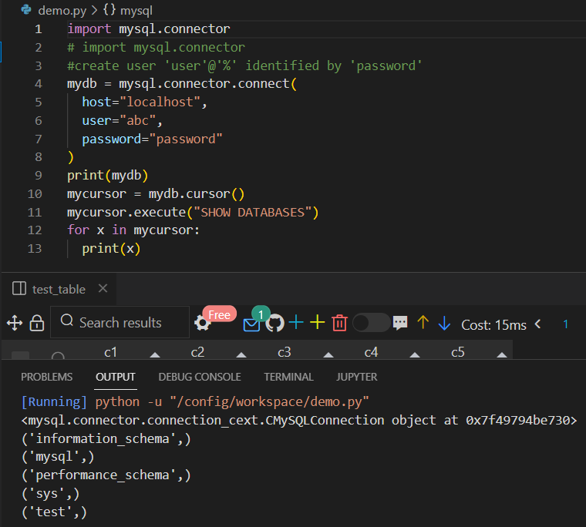

mycurosr.execute() can be used to execute the queries in python.

Now, suppose you want to create a new table in database but not using SQL and by using Python.

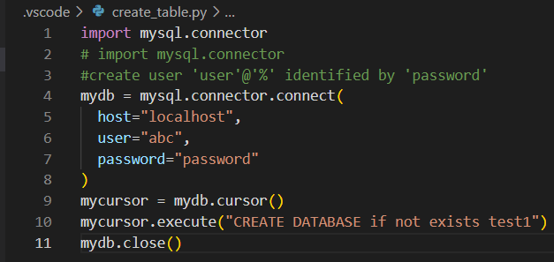

By running above code, a new database will be created.

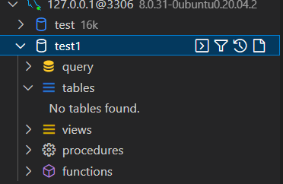

TO CREATE TABLE IN A SPECIFIC DATABASE:

Create table if not exists databas_name.table_name()

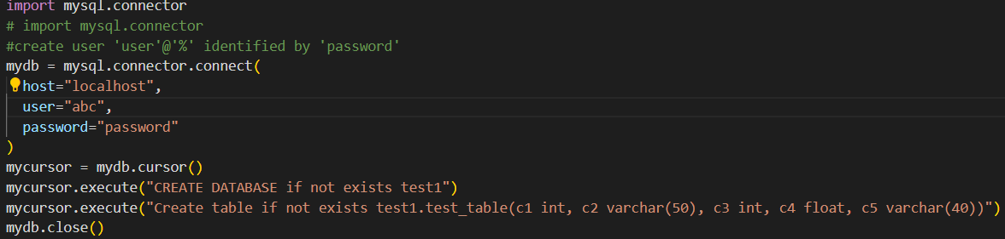

Hence, in this way you can create a table in a database using python.

Side-by-side, check database changes in vs code itself.

Now, to insert value in table

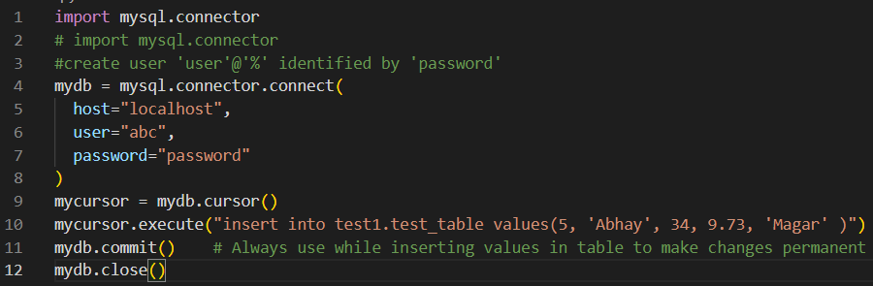

You can check the value inside the table using mysql.





You can check the value inside the table using Python.

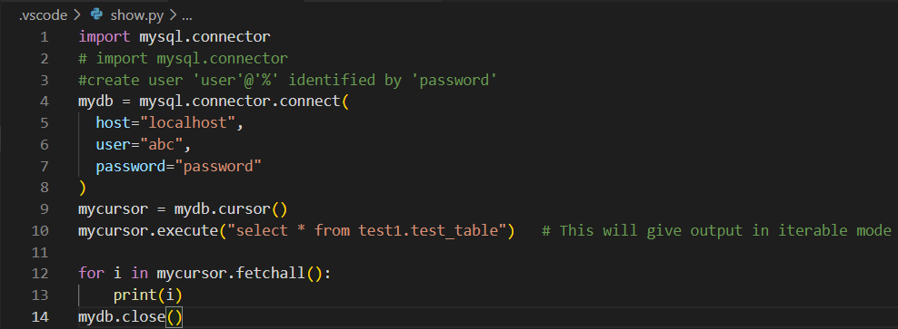



Hence, in this way, we have studied how to connect python to MySQL.